**Sweet Sauteed Corn**

2 Tablespoons extra virgin olive oil  
1 red bell pepper, finely diced  
1 green bell pepper, finely diced  
½ Cup finely diced white onion  
4 ears fresh corn, kernels removed  
½ teaspoon salt  
¼ teaspoon pepper  
2 Tablespoons butter  
3 Tablespoons honey

1. Heat oil into a large skillet over medium heat. Saute red and green bell pepper with the onion for 5 minutes, stirring often. Stir in corn, salt and pepper. Cook for an additional 5 minutes. Stir in the butter and honey until well combined and melted through. Serve warm.

**Smoky Mashed Potatoes**

5 lbs washed, peeled and cubed potatoes  
½ stick butter (4 tablespoons)  
1 1/2 Cup milk (more if you like thinner mashed potatoes)  
8 oz sour cream  
1 ¼ teaspoons salt (or to taste)  
¼ teaspoon pepper  
1/2 teaspoon garlic salt (Lawry’s)  
4 Tablespoons adobo sauce (from canned chipotles, add more if you like it spicy)

1. Boil potatoes for 12-15 minutes or until fork tender. Transfer drained potatoes to a large stand mixer bowl with the butter. Start to mix on low speed until mashed. Add milk, sour cream, salt, pepper, garlic salt and adobo sauce until well combined. Taste and season accordingly with additional salt/garlic salt if desired.

**Adobo Peach BBQ Chicken**

18 chicken tenders  
1 1/4 Cups Peach preserves  
¼ Cup adobo sauce (canned chipotle sauce), add more if you like it spicy hot!  
½ Cup BBQ sauce  
¾ teaspoon salt  
2 cloves fresh garlic, minced

1. Place chicken tenders into a large zip lock bag. Pour in peach preserves, adobo sauce, BBQ sauce, salt and garlic. Marinate for at least 1 hour.

2. Preheat indoor grill pan or outdoor grill to medium high heat. Spray grill with cooking spray. Grill chicken for 3-4 minutes per side or until cooked through.

[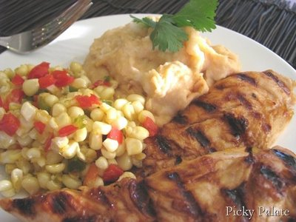](http://2.bp.blogspot.com/_cGPg0Rl228w/SE4oefnI-ZI/AAAAAAAAC4Q/b2VwxDqN1FM/s1600-h/IMG_6042-Titled.jpg)Adobo Peach BBQ Chicken with Smoky Potatoes and Sweet Sauteed Corn